**ASSIGNMENT**

Wordpress account: <https://wordpress.com/view/panneerdigitalmarkter.wordpress.com>

Canva account : <https://www.canva.com/settings>

Create a poster by using canva

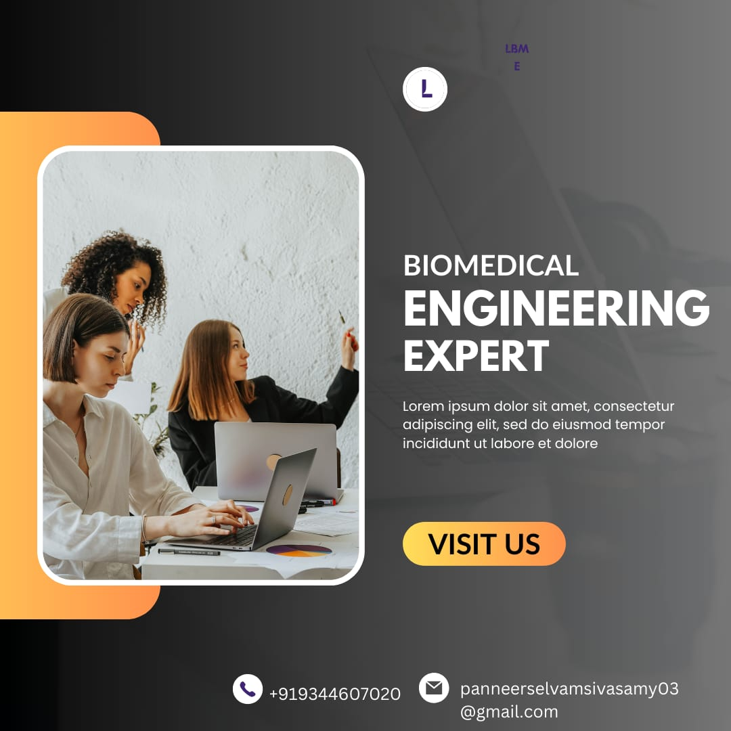

Social medial links:

Fbb : <https://www.facebook.com/profile.php?id=61552247464494&mibextid=ZbWKwL>

<https://www.facebook.com/profile.php?id=61552247464494&mibextid=ZbWKwL>

Instagram

<https://instagram.com/biomedical_academician?igshid=OGQ5ZDc2ODk2ZA==>

Create a newsletter by using canva :

